**Results**

*Mercury Thermometer (constant pressure)*

Four measurements were taken for water temperature and 1-dimensional volume (position of the mercury drop) for a total of $8$ measurements. Pressure was held constant at $101.325 kPa$ as was the amount of gas, $n$.



An initial volume of $61.5cm$ at a room temperature of $24℃$ was recorded. The first container, filled with ice water, was poured in the funnel until the thermometer reached equilibrium. Volume of the mercury drop lowered to $57cm$ at a temperature of $7.5℃$. Warm water was poured into the funnel next, again giving the thermometer time to reach equilibrium. Once equilibrium was reached, the mercury drop had reached a volume of $66.1cm$ at a temperature of $45.5℃$. Following the hot water, steam was routed into the thermometer, giving a volume reading of $66.1cm$ and $98℃$. Figure 1 shows the plot of this data with a linear regression model.

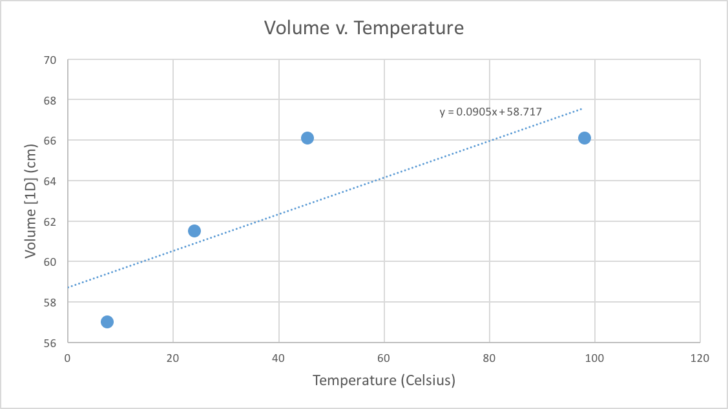

Figure : Mercury Thermometer Volume v. Temperature

*Constant Volume Gas Thermometer (Sphere)*

Similar to the constant pressure mercury thermometer, there were 4 measurements taken for two different parameters in this portion of the experiment. The sphere was held at constant volume. Four measurements were taken for both sphere temperature ($℃$) and pressure ($kPa$), resulting in a total of measurements. After all data was obtained, a calculation for absolute zero temperature ($℃$) at $P=0$ was made.



With the sphere submerged in ice water, it’s temperature was $5.8℃$ with a pressure of $14kPa$. Following the ice water was warm water submersion with a temperature of $52.6℃$ and pressure of $16kPa$. This trend was expected to continue as the temperature of the water increased. At boiling, the temperature was recorded to be $97.8℃$ with a pressure of $18.5kPa$.

Figure 1 below shows the plotting of the data gained from experiment, along with a calculated value of what absolute zero would be given our values and a linear regression model1.

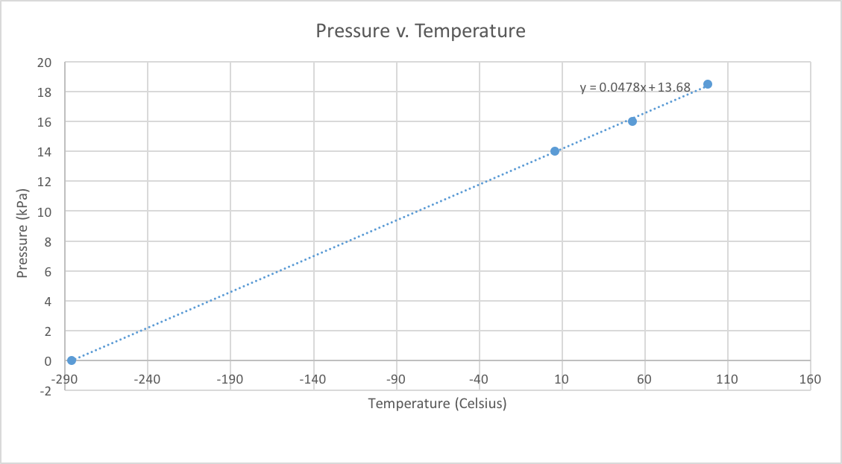

Figure : Pressure v. Temperature with linear regression & absolute zero calculation

The linear regression shows that, using the collected data, absolute zero temperature in Celsius is $-286.22℃$. There is an error margin of $4.8\%$ when compared to the known value of absolute zero, $-273.15℃$.

Appendix

1. This value was calculated using the following expression: $t_{abs.zero}=\frac{\left(t_{b}-t_{f}\right)\left(-P_{f}\right)}{P_{b}-P_{f}}$ where subscripts $f$ and $b$ represent *freezing* and *boiling*, respectively.